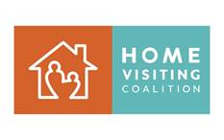
August 3, 2020
Day of Action Tweets

Invest in our children’s future, increase home visiting #MIECHV funding by $100M.
Congress: unleash the power of #homevisiting to help meet the needs of vulnerable children and families isolated at home due to #covid19! Give MIECHV #homevisiting the flexibility and resources for remote connections, emergency supplies.
Home visitors are a crucial part of the #covid19 safety net for young children and families. With additional flexibility and resources for virtual home visits and emergency supplies they could do even more. #MIECHV #homevisiting #homevisiting
Families need support more than ever to get through #covid19. Congress should provide $100 million to help #MIECHV home visitors stay connected to families with young children remotely and deliver emergency supplies #homevisiting #homevisiting
MIECHV Home visitors are working through the pandemic to support families with young children through #covid19. They need flexibility and resources to stay connected remotely and deliver emergency supplies. #homevisitingworks #homevisiting
#MIECHV #HomeVisiting can be a lifeline for families through #covid19. Congress should provide $100 million to meet their emergency needs. #homevisitingworks

